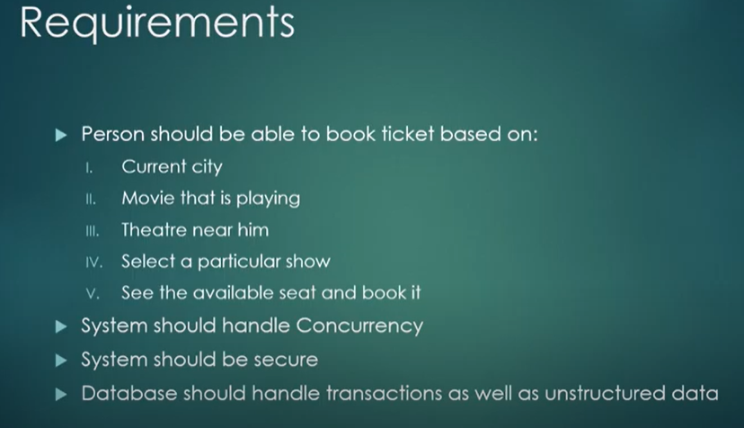

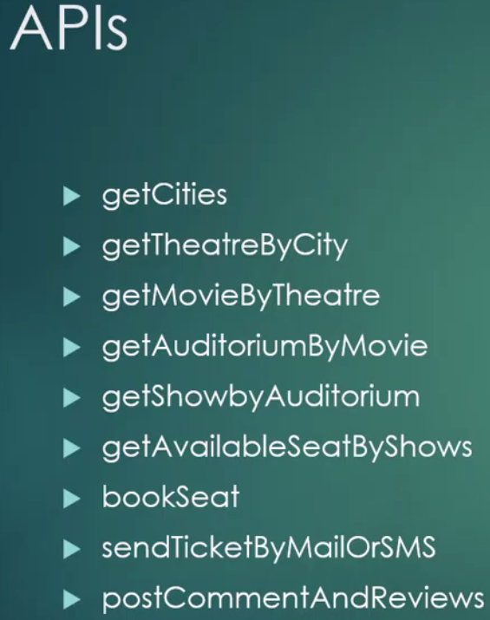

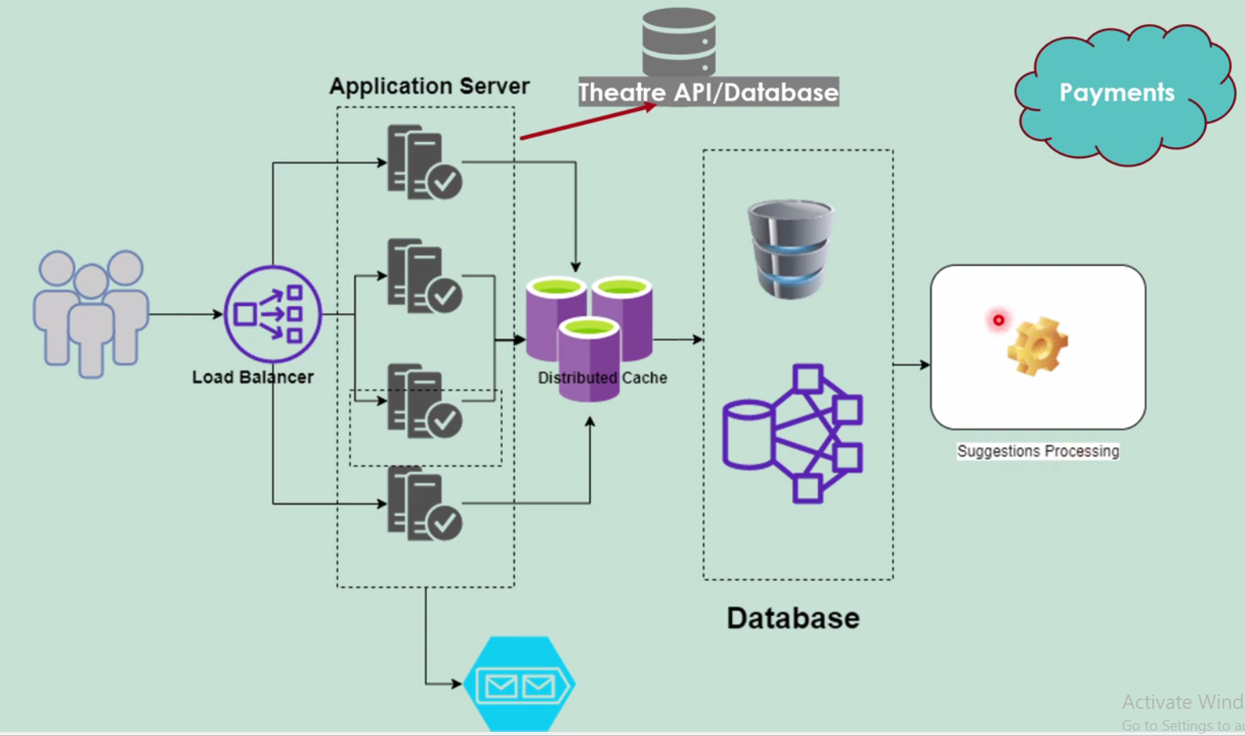

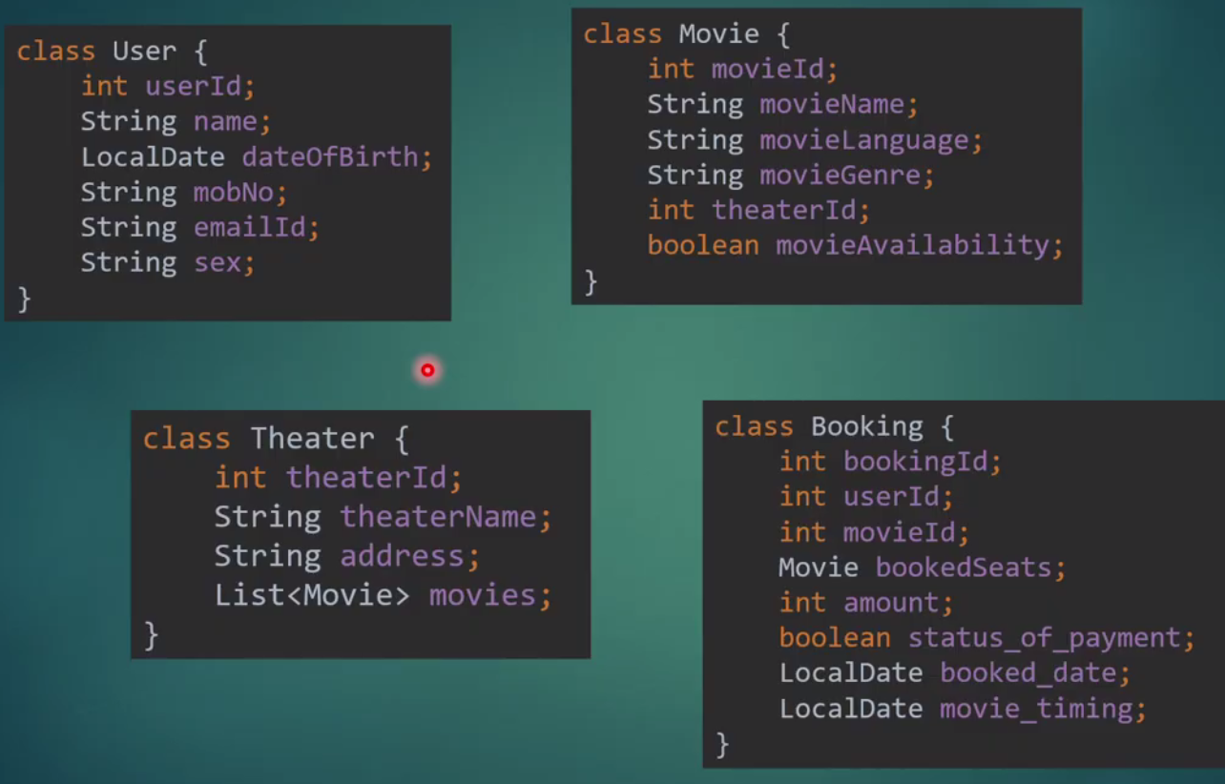

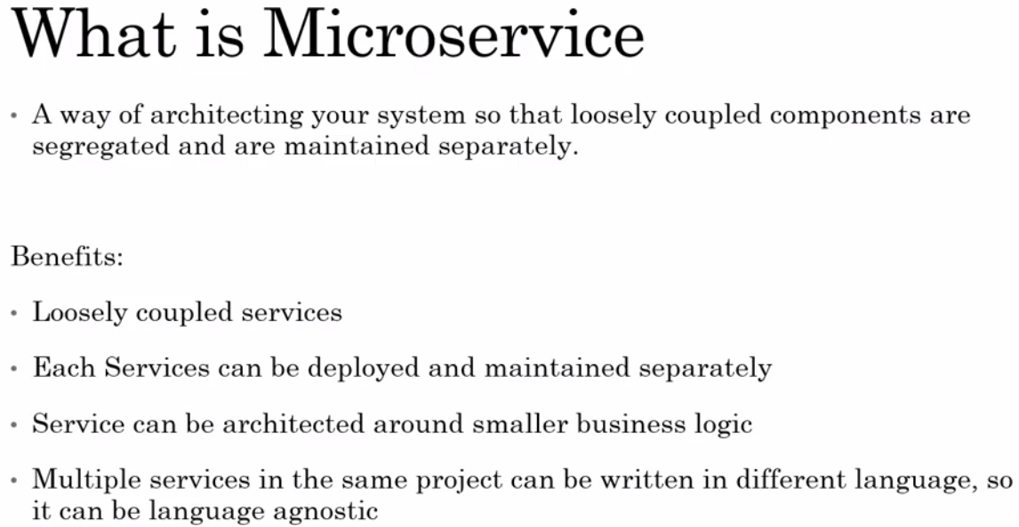

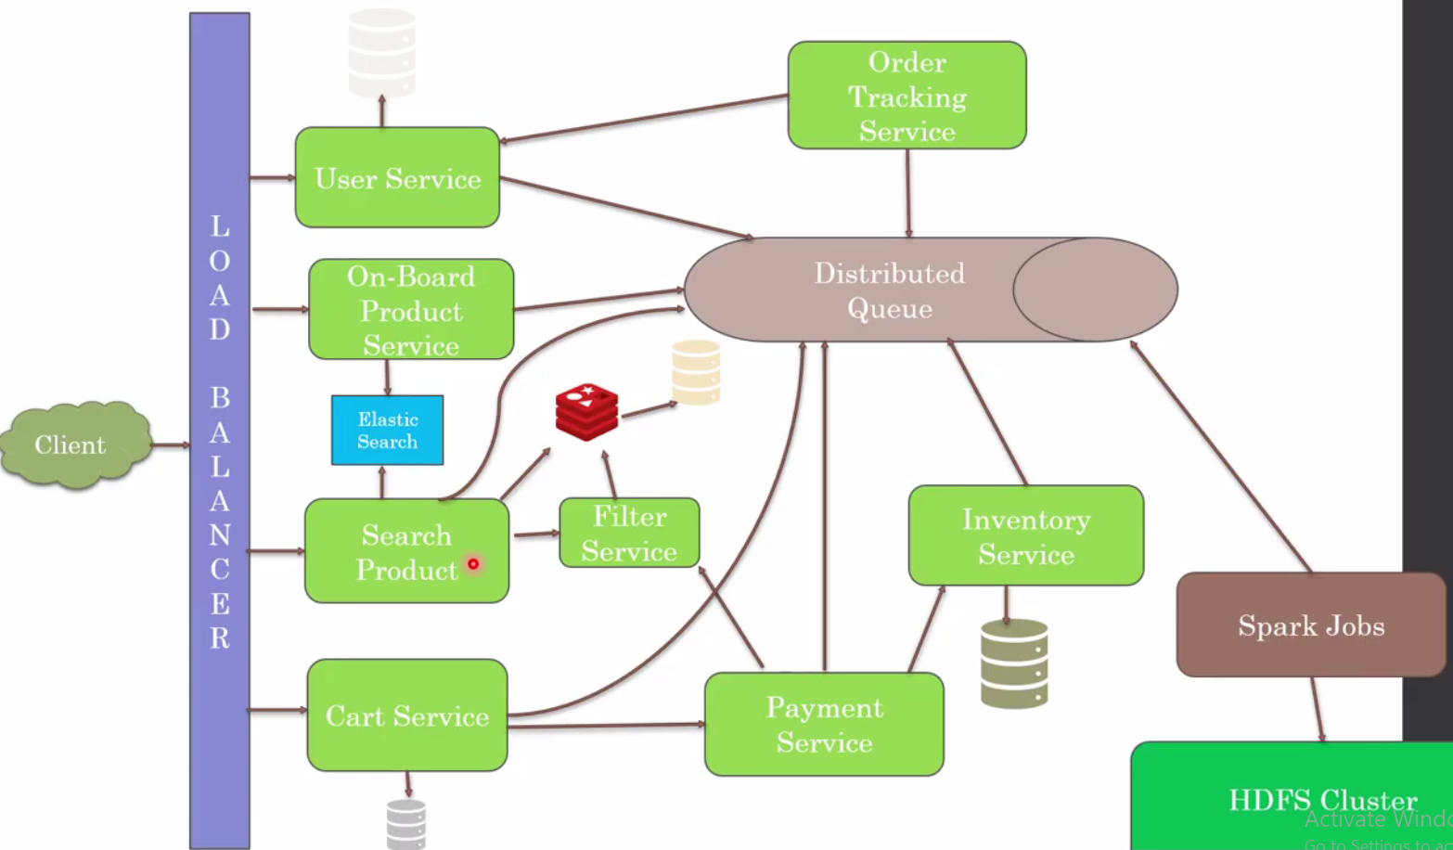

One more benefit we can increase or decrease the number of instances of the particular service based on the load vertically, while in case of monolithic architecture it is not possible to increase or decrease the instance of the particular module having the one of the functionality.

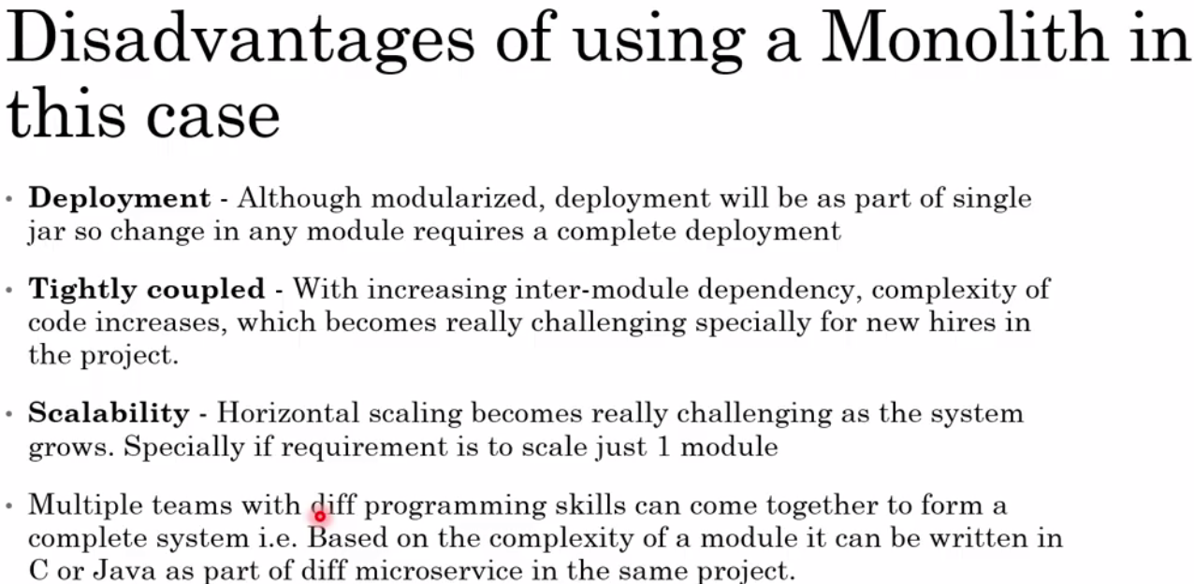

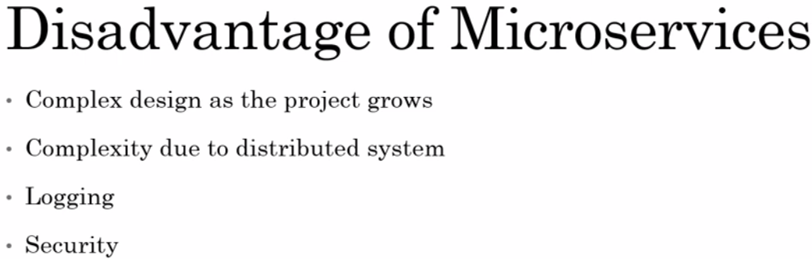

So in case logging every Microservice log should be centralized just to check and track the all the microservices.

In case of monolithic we used to have only one application with all the functionality so it is easy to implement security at the application level and which further secure the internal module as well. But in case of MS, it is deployed in distributed system so to manage the security is not an easy job.

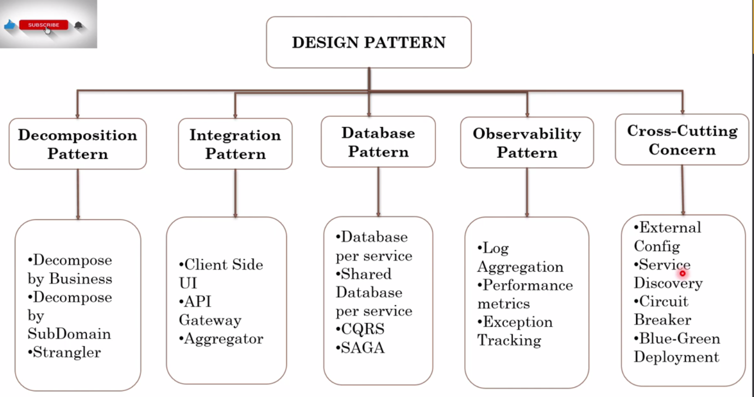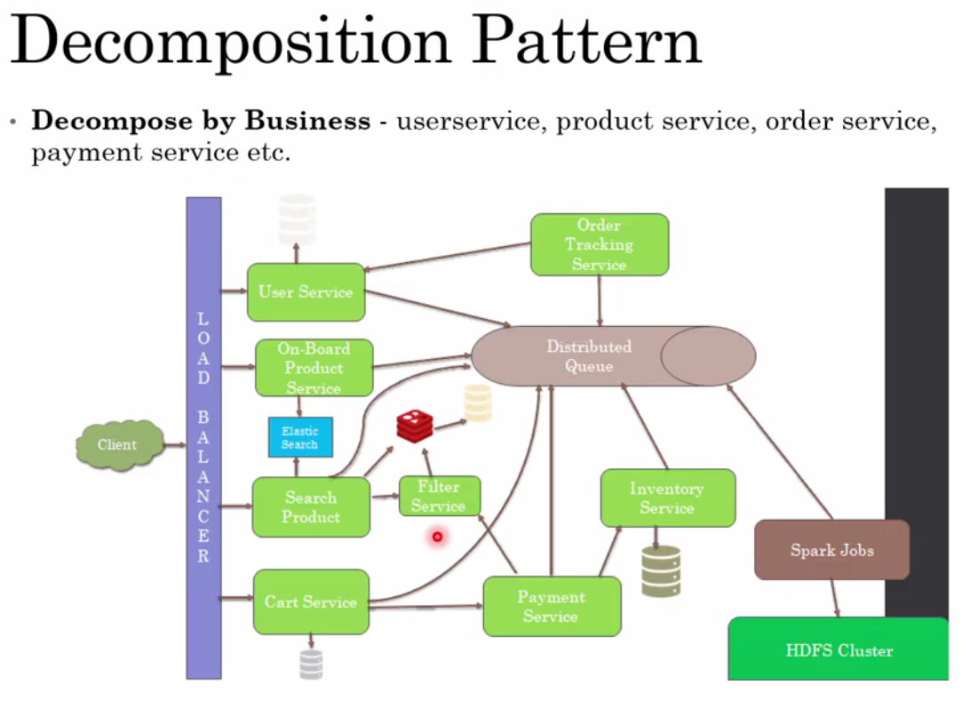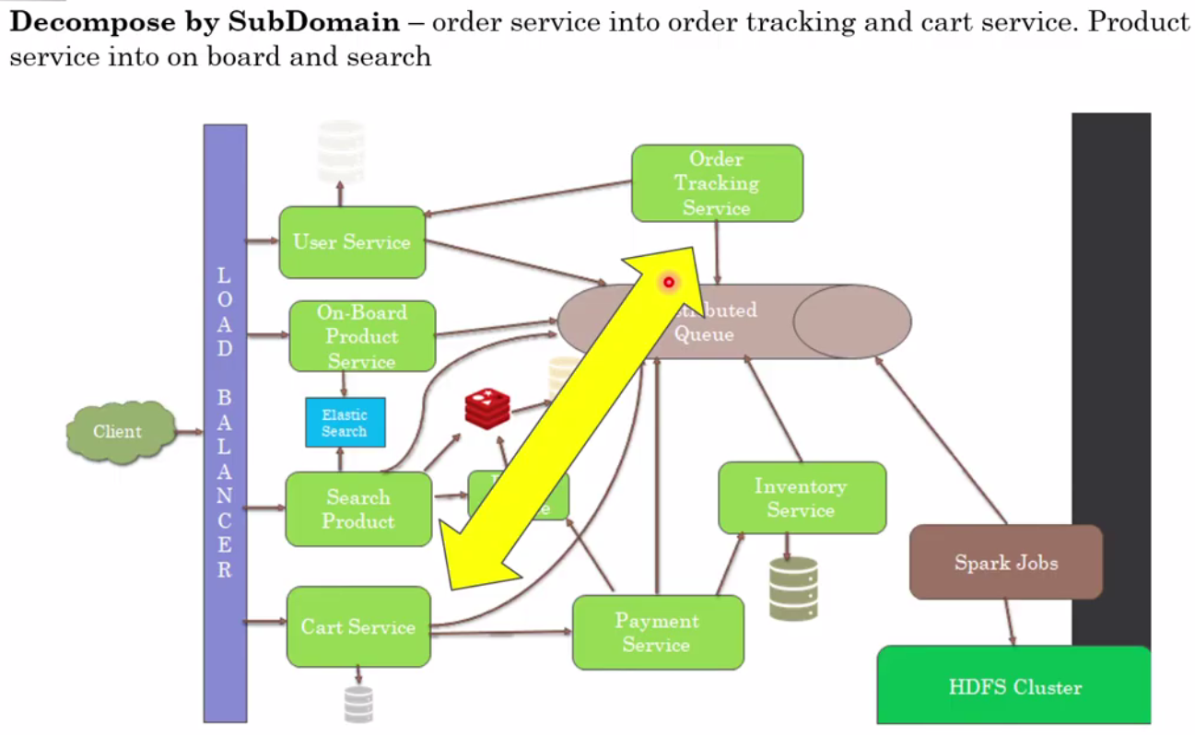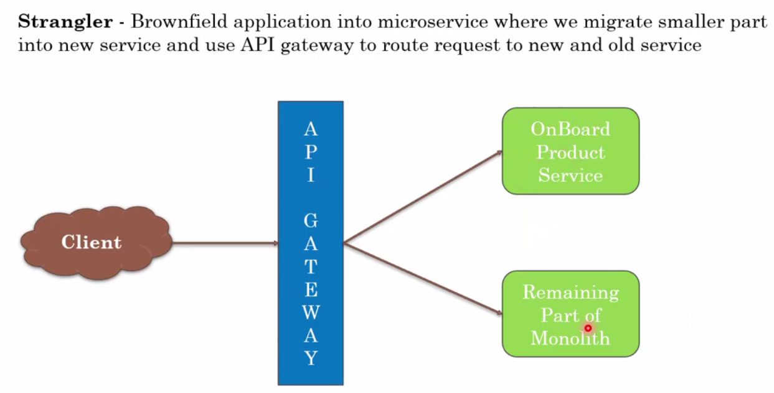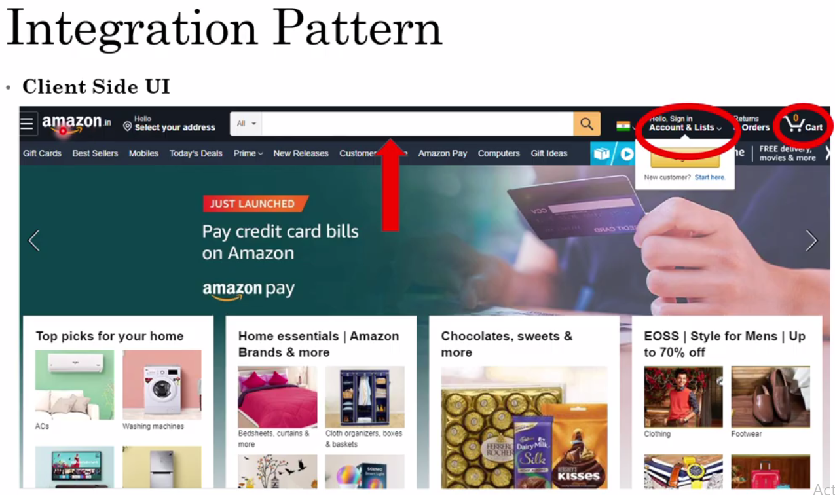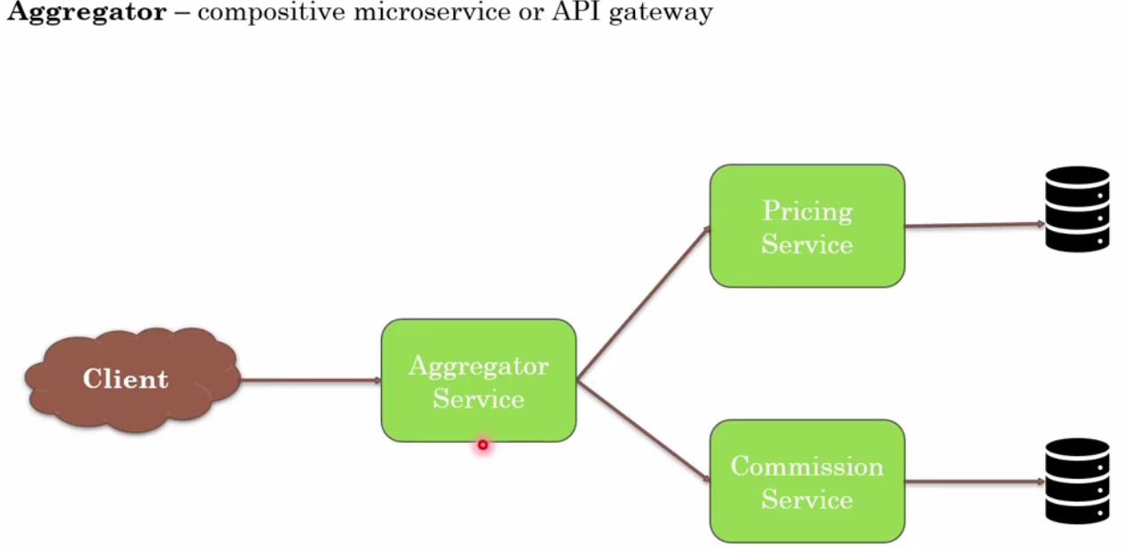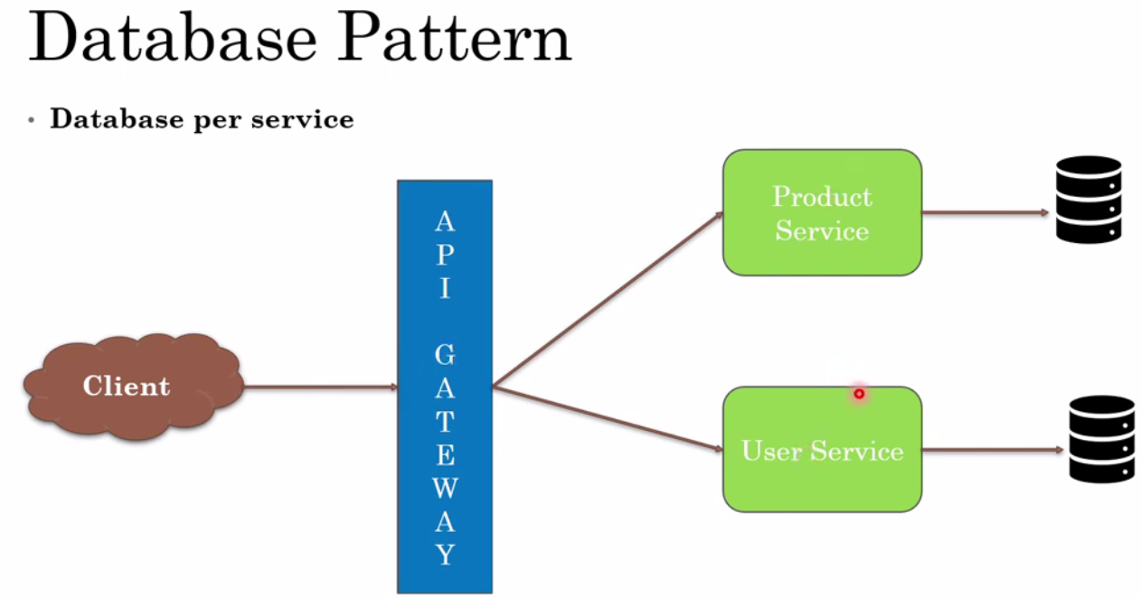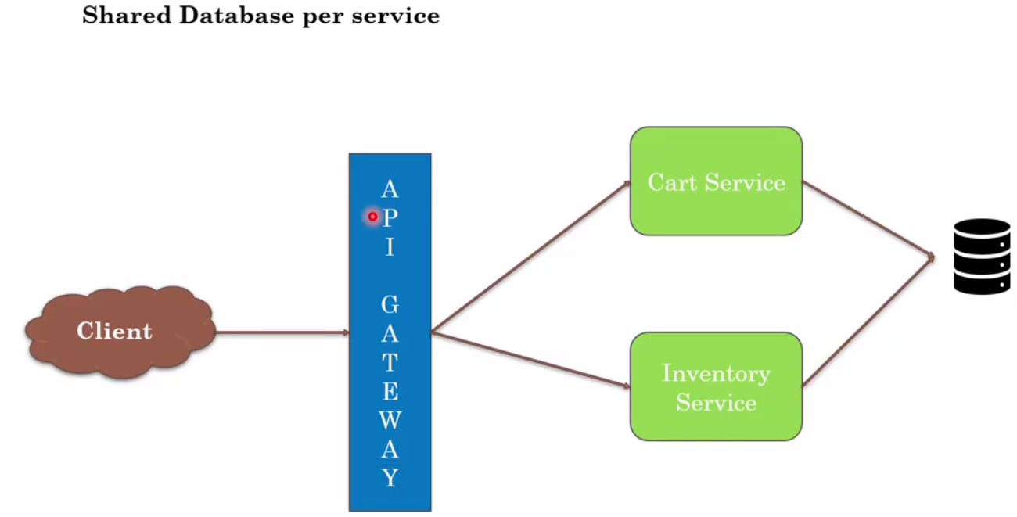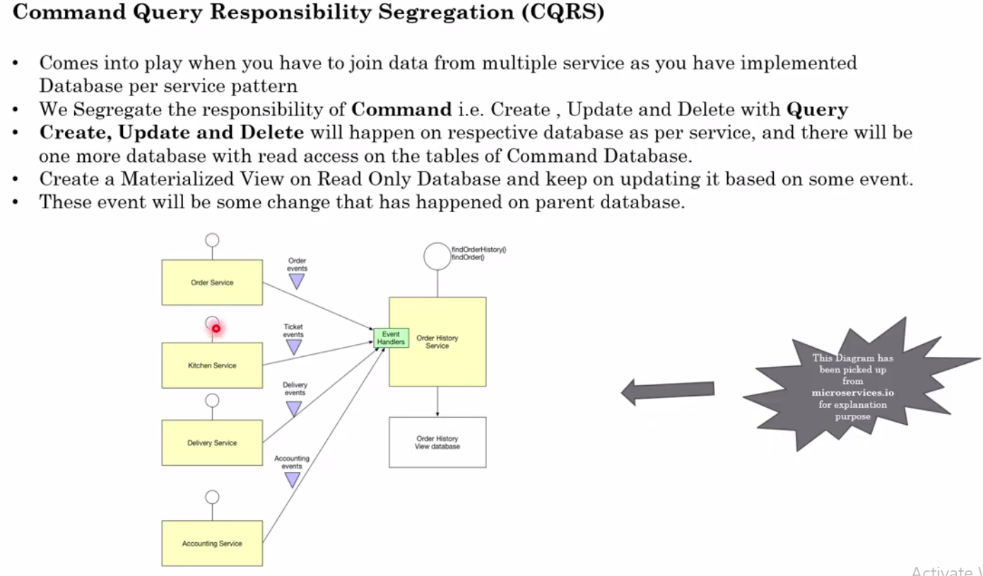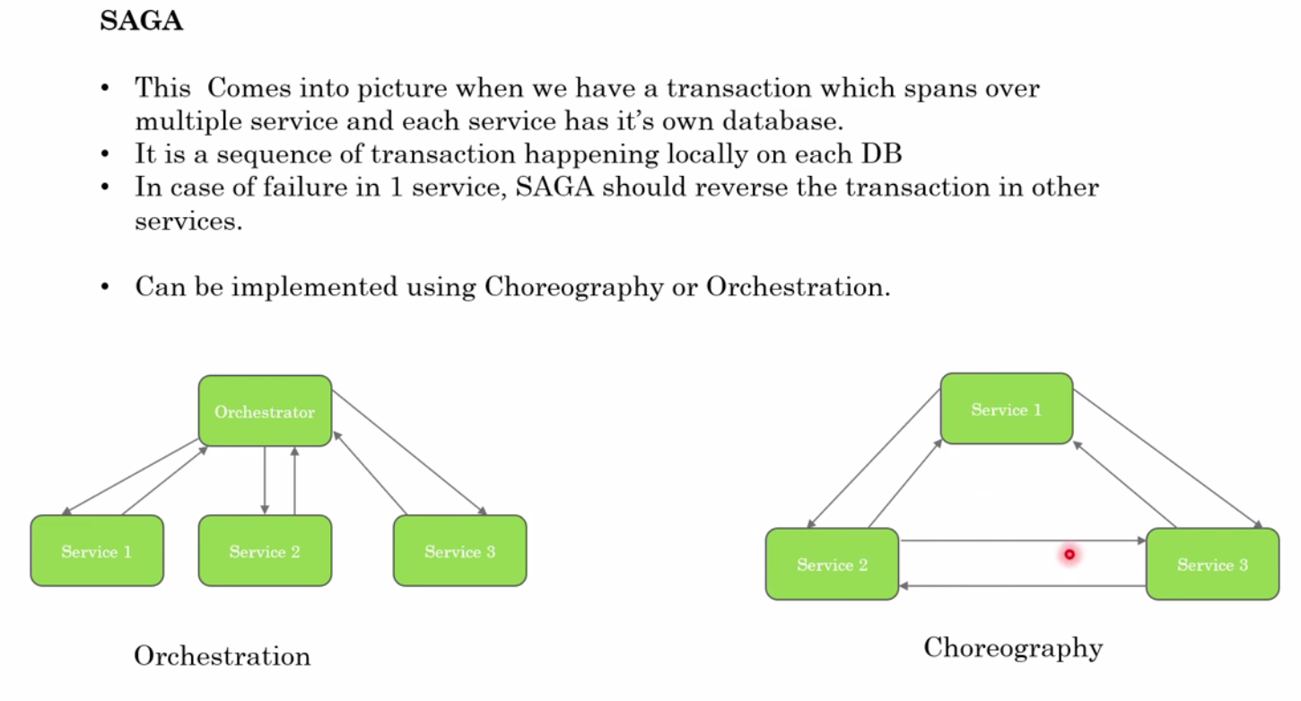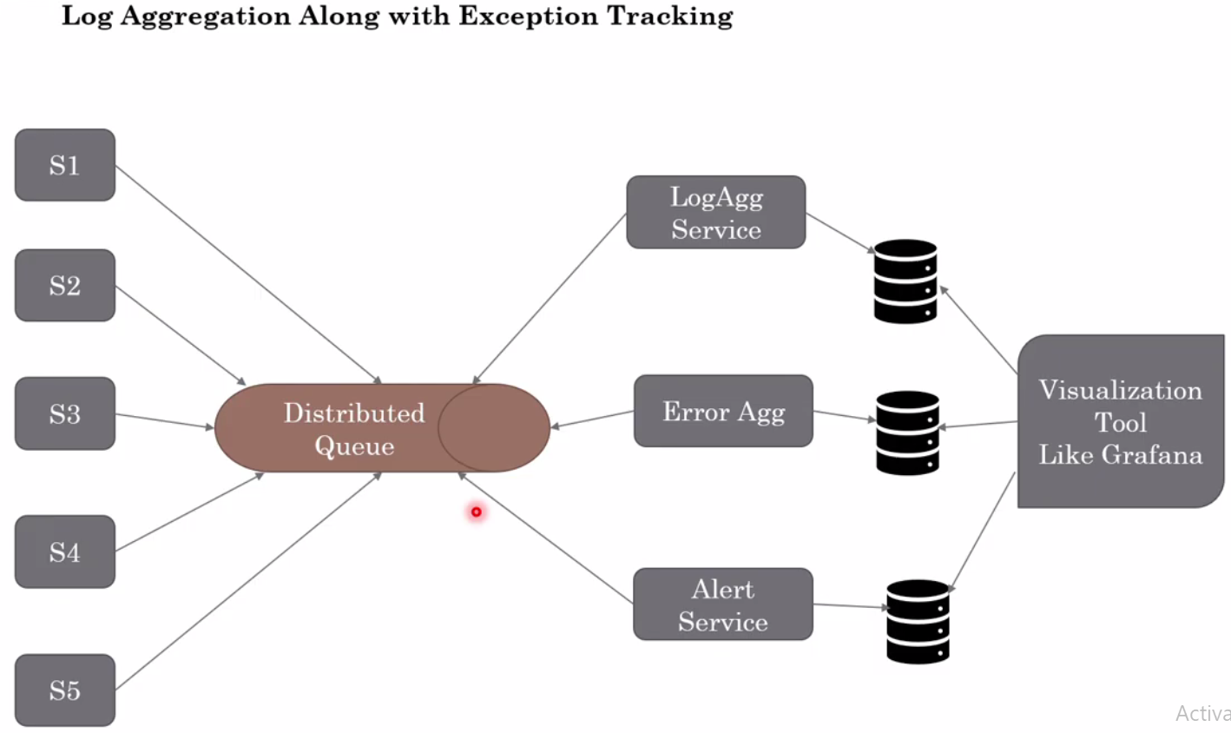



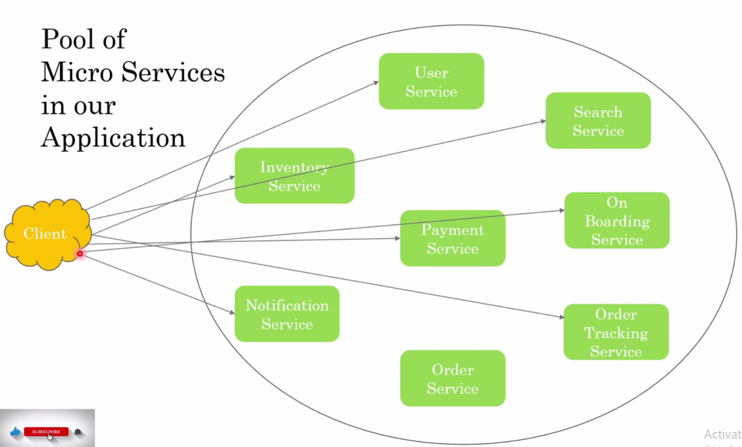

As we discussed earlier in microservices architecture we have a bunch of microservices deployed in a distributed manner and now let’s say as per the above image if any clients wants to call any particular service deployed in the pool then we have to know the particular IP address and host name for each of the services and hence if there is 1000 MS, then each service needs to be configured with its IP address and apart from that the biggest headache for the client is that client has to remember each service IP address or host name to call the particular service and as per the above diagram its looks tightly coupled and very difficult to maintain all the connections. And later if service gets deployed to any other IP address then it has to be communicated properly with the client. 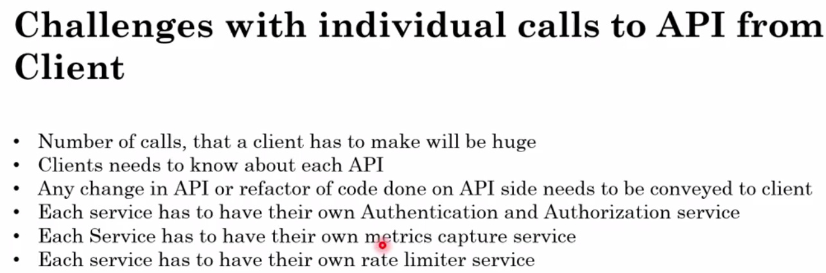

So the solution the above problem is API Gateway.

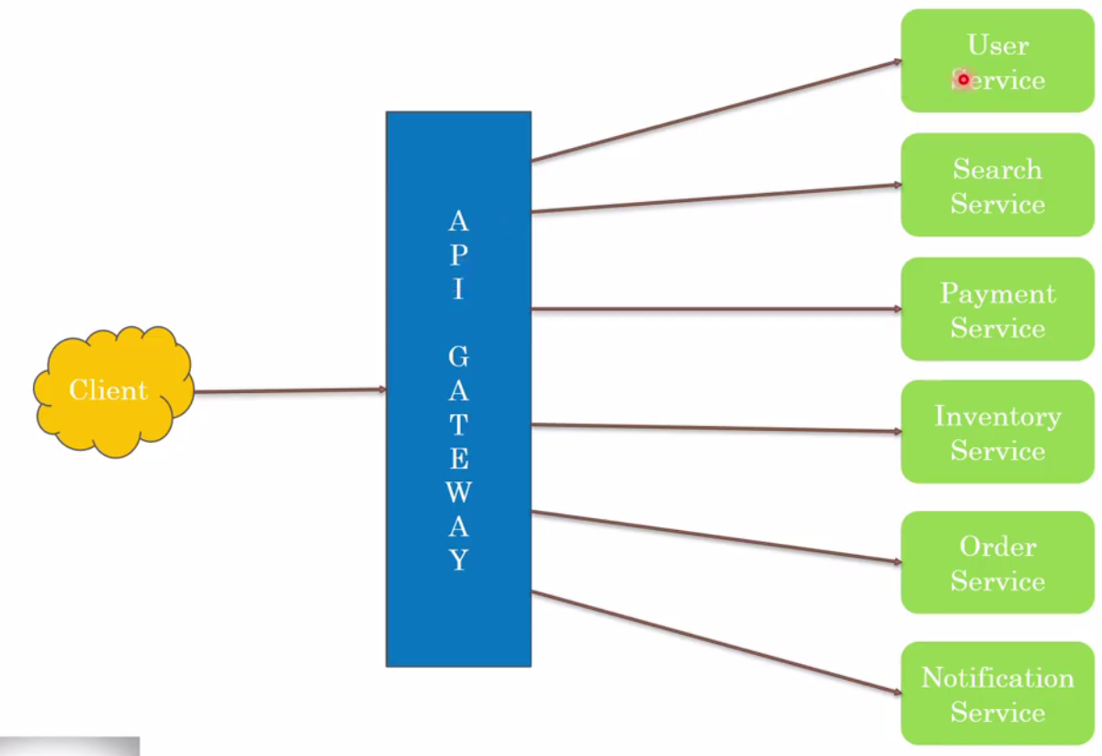

* API Gateway will work as abstraction layer which will work as gate way for these services and for the client API gateway is just an interface in the form of URL that client will configure to call any of the microservices.
* Client will make one call to the gateway and it the API Gateway responsibility to call the particular Microservice based on the URL that client sends to API Gateway. For example if client sends URL like [http:amazon.in/user] then it is the API gateway responsibility to map this call to User Service.
* Apart from auto URL re-direction we can configure authentication & authorization at the API gateway level because this kind of the front level security for all the microservices.
* Even Matrix capture part we can put at API gateway level because API gate way will all the information like load, traffic, number of instances etc.
* One important thing, it might happen that client can make Socket connection to API gateway but post API gateway all the connection will be http connection.

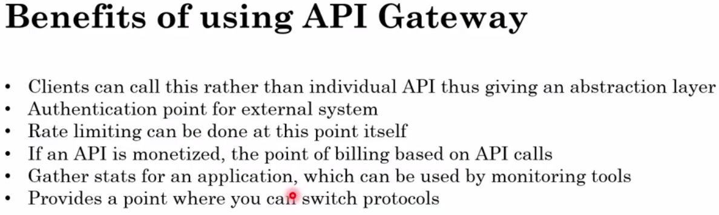

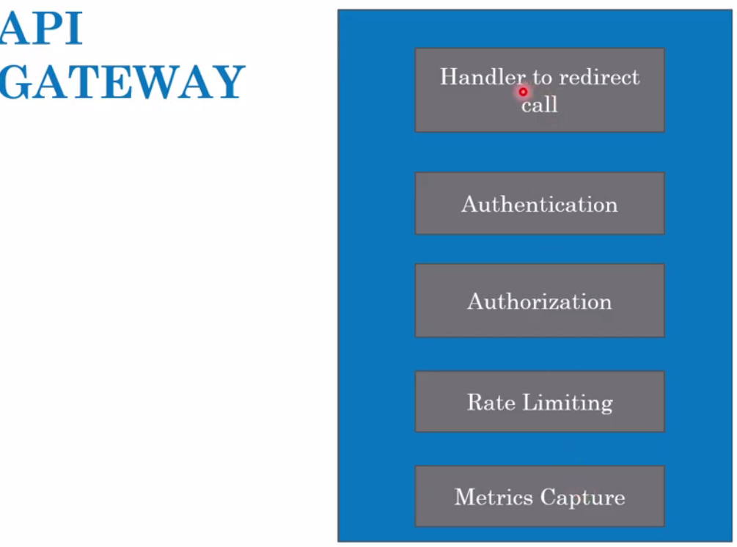

So at the API gateway we can incorporate the several functionality for all the services at the centralized location rather than incorporating in every service.

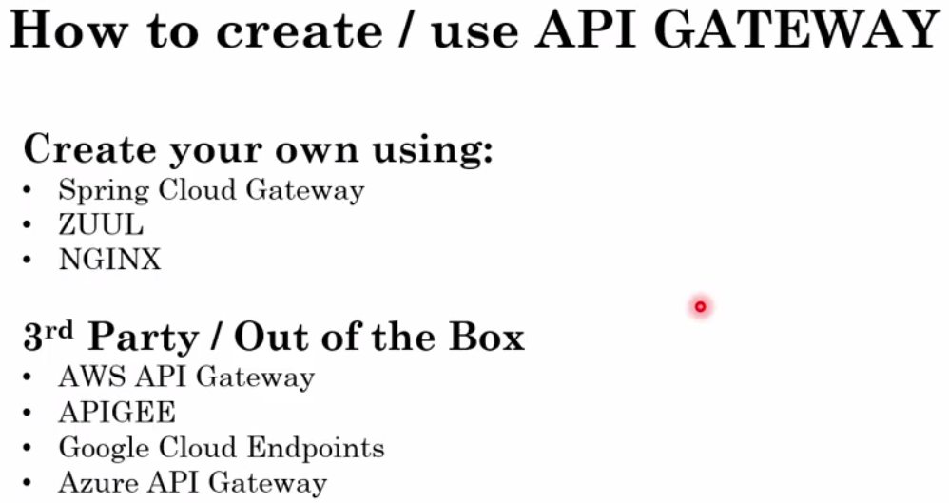

If we are using spring then we can use any of the three to create API Gateway and if we are using 3rd party then we can use any of the given from the 3rd party.



|  |  |
| --- | --- |
|  |  |

As in the previous discussion we have seen that API gateway plays a very important role in routing the client request to the particular microservices. Here API gateway has mapping configuration which helps in invoking the microservices based on the request came from client. So till here everything looks good but challenge comes when we have multiple instances of the same microservices like show in the second image.

So in this case we have to configure each of the instances from the API gateway, but now a days when the deployment process is automated using Docker or Kubernetes so during the deployment we just need to mention the number instances and the instances gets created automatically during the deployment and a dynamic IP and port gets assigned to all the instances, and apart from that based on the load the instances keeps increasing and decreasing automatically (takes care by load balancer).

So in this case API gateway does not have any information (like IP and port) about number of running instances of MS so API Gateway would not be able to route the request to the instances of the MS.

So when deals the situation like this then the concept of service-discovery comes into picture. So as the name suggest, in the service-discovery there will be a mechanism using which the client will be discovered that where the instances of the services are running. It might happen that service-discovery is happening at the API gateway layer itself where basically we configure the address of service discovery and ask the service discovery to give me back the list of URL and port number of all the instances of the running services.

Next we will talk about.

* How the service-discovery works
* How many different type of pattern involved as the part of SD
* How each service will register themselves with SD or service registry
* How the API-Gateway or the client will get the right URL and port from the service discovery so that the respective service can be invoked

**Discover Pattern:**

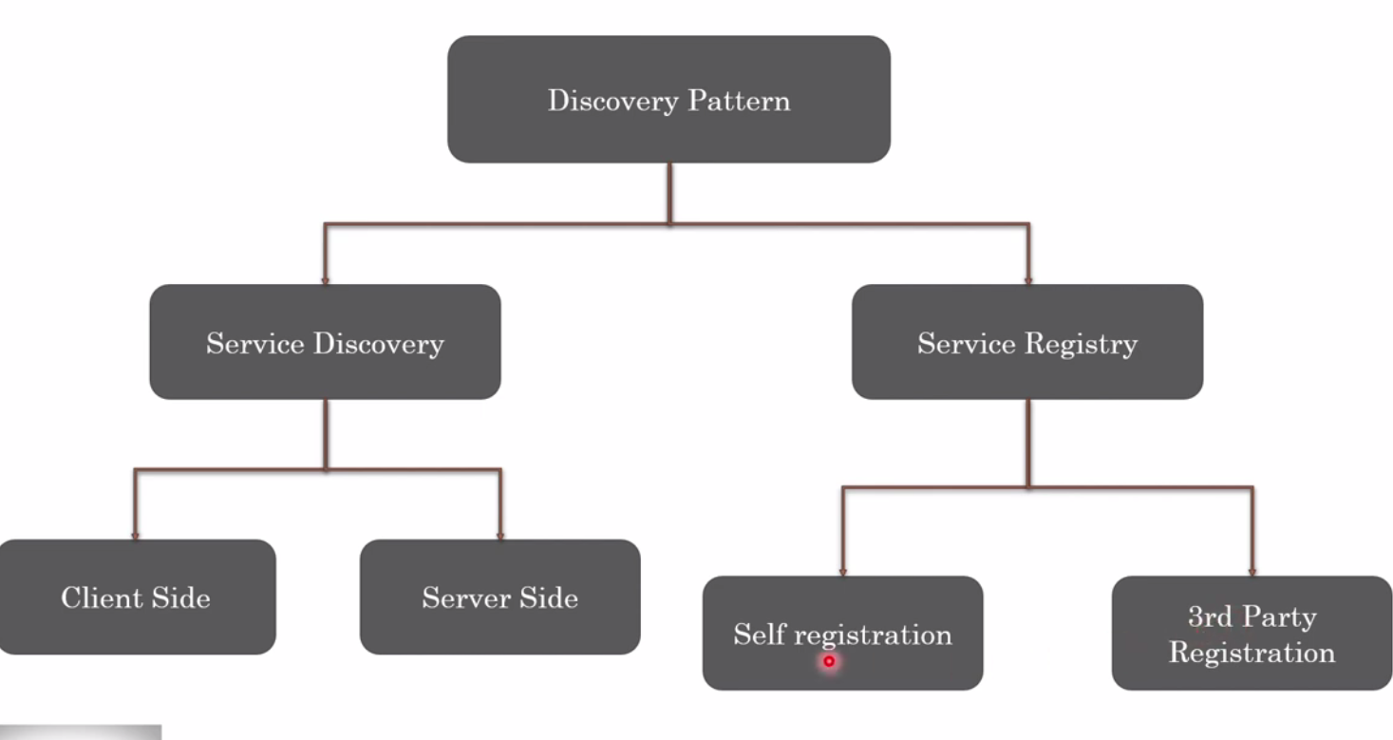

Discovery Pattern can be divided into two parts-

1. Service Discovery : This discovery can be either from client side i.e. in this case client should know that how many instances is running or from server side
2. Service Registry: So when instances gets increases or decreases then either service will do the registration itself or by 3rd party

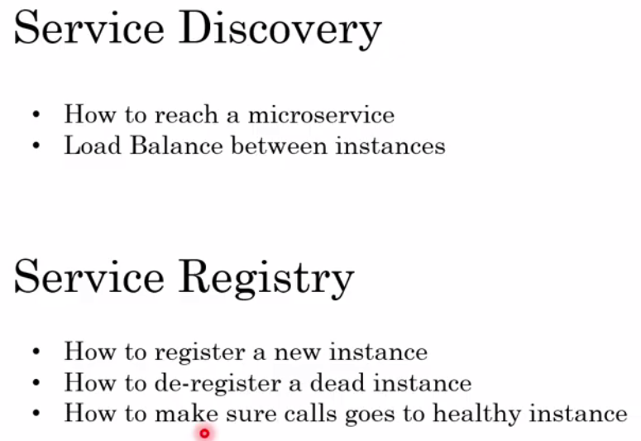 Service Discovery and Service Registry will help us in giving the answer of the above question.

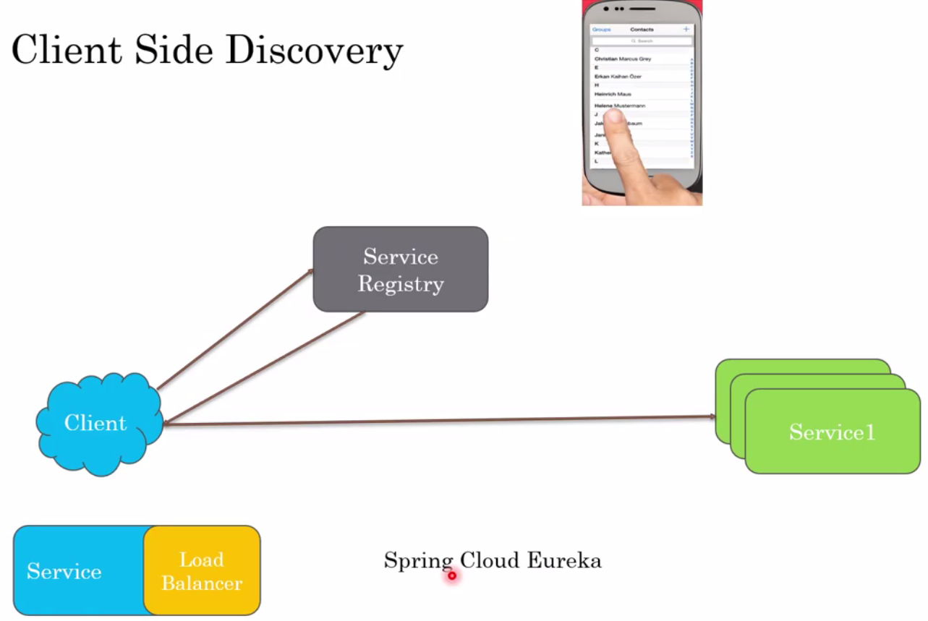

So as per the above image the CSD is very similar to phone book directory where user itself has to find out the particular number to call other person.

Similarly in the CSD, when any client will have its own Service Registry (it could be MS also) and if client wants to call any particular service then first it will call the service registry and will ask URL and port of all the active running instances. Now the client (It could be a MS) will call the particular instance and balance the load in all the running instances.

So this client would have service component with its own business logic and built-in load balancing inside it.

One of the examples is Spring Cloud Eureka which would have its own client and load balancer.

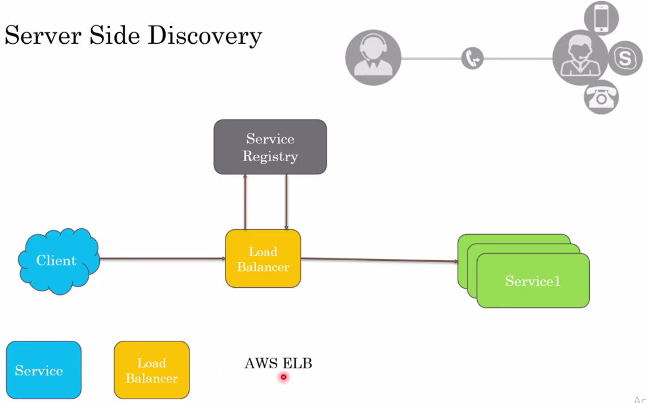

It is very similar to call center where if person call for any solution then first it will go to first layer contact (Reception) and if the reception is not able to give right answer then it will route the call to specialist person who can solve the person’s query.

In the same in the SSD the client want to talk to any of the instance of service1 then, first client will send the request to Load Balancer and then load balancer then send & ask the Service Register about URL and port of all the active running instances so that load balancer could send the client request further to instances of Service1 and can balance the load among all the active running instances.

Here this load balancer and service Registry will reside outside of client application

One of the good examples of server side discovery is AWS ELB.

Now next will talk about registration like how the service registry happens?

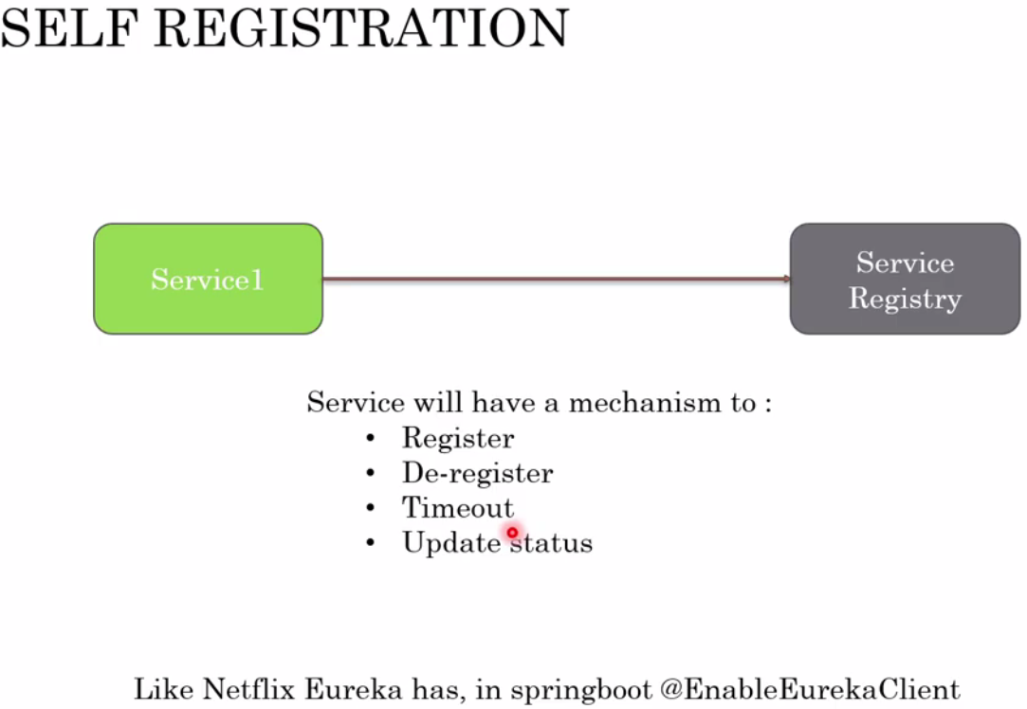

As part of self registration, it is each service responsibility to register itself with its URL and port with Service Registry, each service will go to Service Registry and will say that this is my URL and port and please register this URL and port with you. Now let’s say if any other instance of Service is running then again this instance will go to Service Registry and will say that I am also up and running and please register my URL and port with you. So this is self registration happens. In case of service down it can de-register itself from the Service Registry.

When any service register itself with Service Registry then service keep sending messages (known as heartbeat) in the particular interval just to inform to Service Registry that I am still active and if Service Registry does not receive the heart beat in a given interval then service registry de-register the service from the registry so that if load balancer ask about the status of the particular instance then it could update the status accordingly.

Example of Self Service Registry is: Netflix Eureka in spring boot, when we include the dependency and configure **@EnableEurekaClient** at the each service

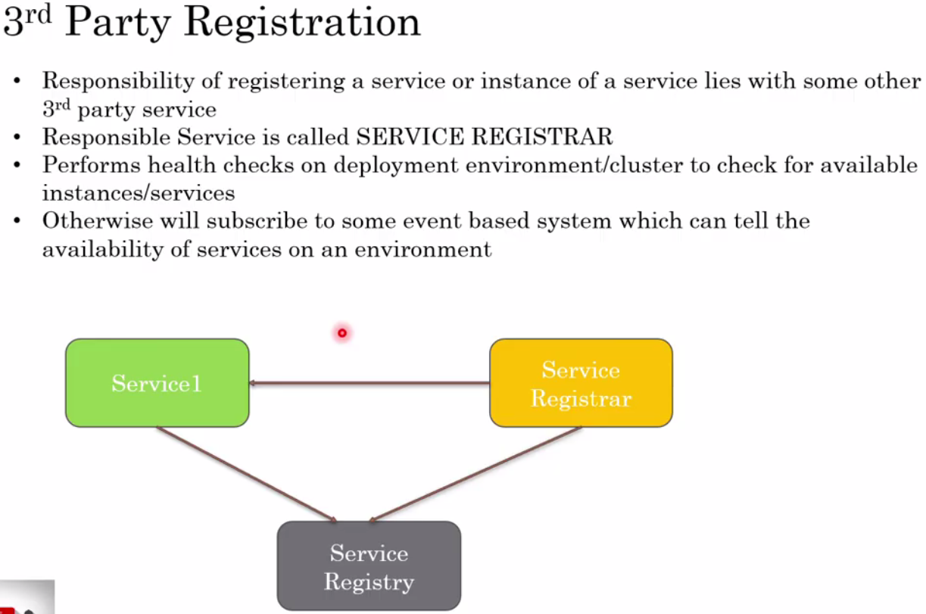

In case of 3rd Party service registration, here we will have one component Service Registrar, which will keep checking the health or heart beat of newly created instance and then it send the message to Service Registry that I got heart beat active for this newly created service so please register its URL and port with you. And in case if Service Registrar does not get the heart beat of the service then it will say the Service Registry to de-register the that particular service from registry.



**Here we will see what circuit breaker is and how it helps in overall MS architecture.**

A circuit breaker is a Microservice only similar to electric circuit breaker

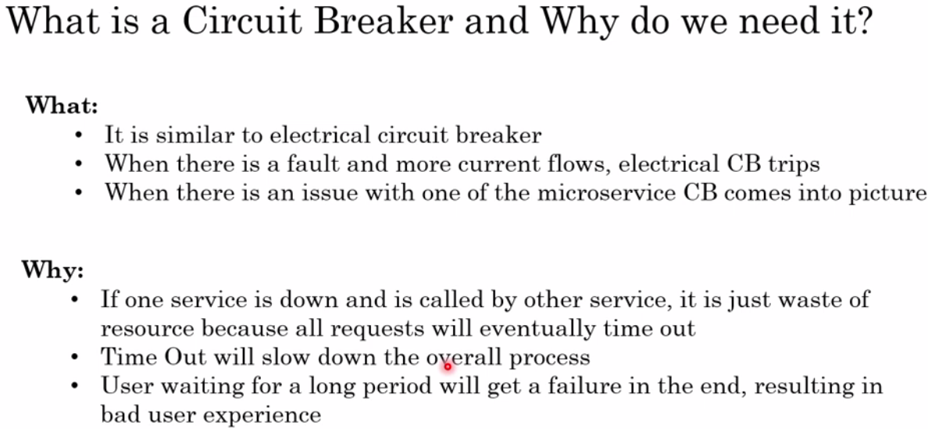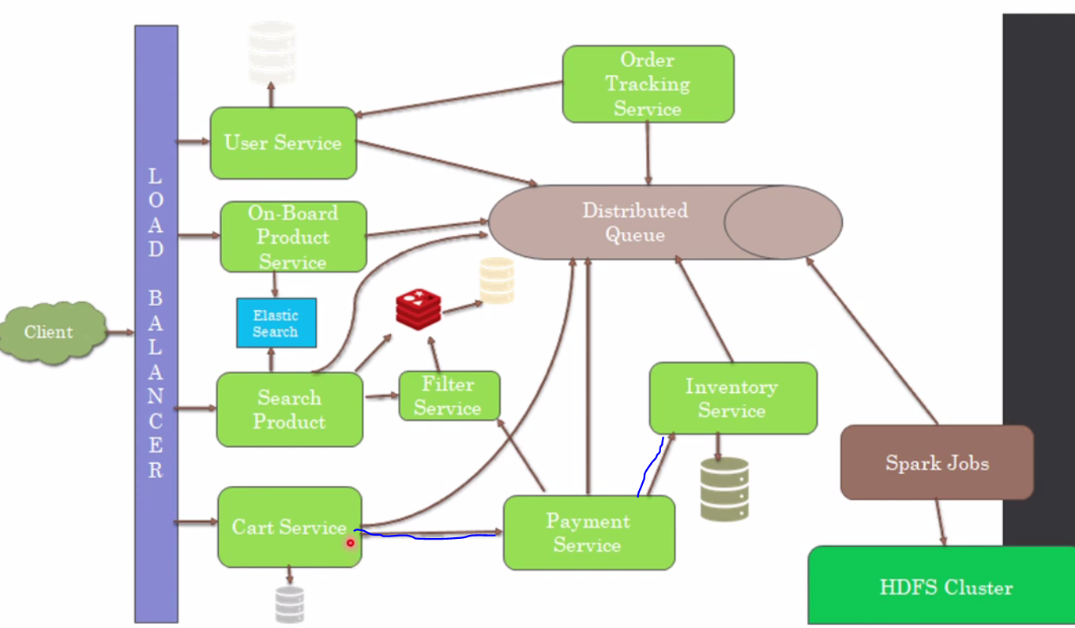 As here we can see that the Cart Service is talking to payment service and Payment Service talk to inventory service. For example when customer place order from the Cart Service then it will go to talk to Payment Service and before doing payment, Payment Service will talk to Inventory service just check whether the product is available in the inventory or not. Now let’s say if inventory service is down then Payment Service will not get any response from the inventory service and in-turn payment will be failed and Cart Service will get payment failure response. And as we know that payment functionally is very important for any business and if it does not work properly then business will affect.

So in this scenario to avoid this failure situation we will implement circuit breaker Cart Service and Payment Service.

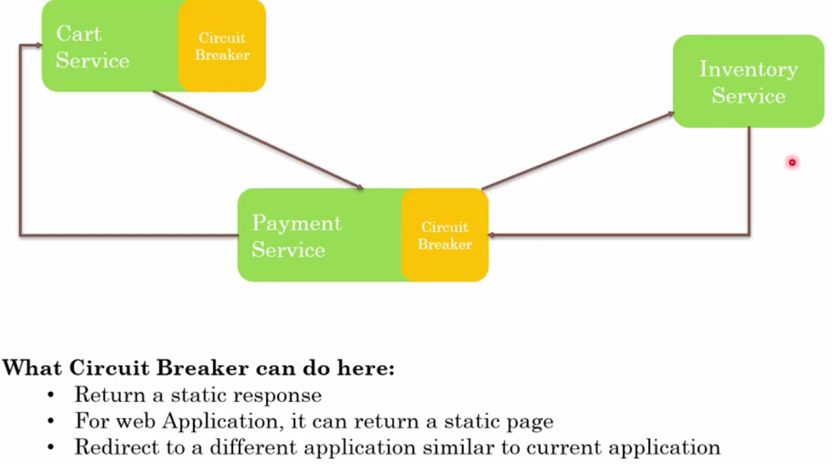

So in the normal flow payment service will get proper response from the inventory service and in-turn Payment Service will provide correct response to cart service like payment successful.

But in case Inventory Service is down or giving timeout because of heavy traffic then what the circuit break will do that it will keep checking heart beat of the inventory service and in case payment service does not receive heart beat from the inventory service and then in this case payment service even will not send request to inventory service and in this case the user will get immediate failure response from the Payment Service instead of waiting response from the Inventory service and then payment service send failure response to Cart Service.

So in case circuit breaker the response will be fail fast.

Some time if inventory service is not providing response then we can configure some external Url in the circuit break we will take the response from the external service and thus we can escape the failure in case of any dependent service is down or time out.

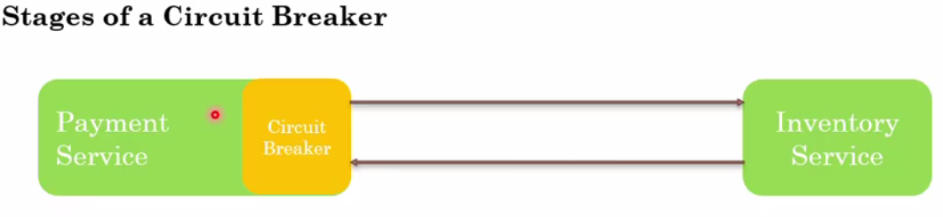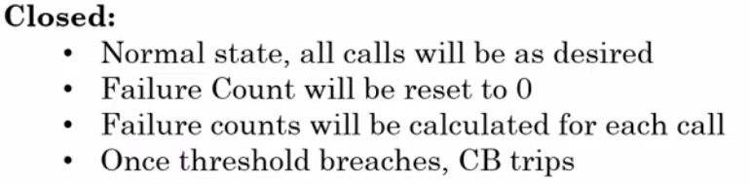

Closed state is nothing but normal state where all the call will be as expected or as desired. Very similar to work like MCV at home, when everything looks fine then everything will be closed state and no break of circuit. In this state

Initially failure count will be zero but in case of failure the failure or timeout from inventory service, then count will start increasing and once the threshold reached to its limit then the payment service is not going to check any health check from the inventory service and will break the circuit.

Note: The threshold is set at circuit breaker level and it keeps checking connection between two services and if it does not receive any response in a given time span then it just trip the circuit.

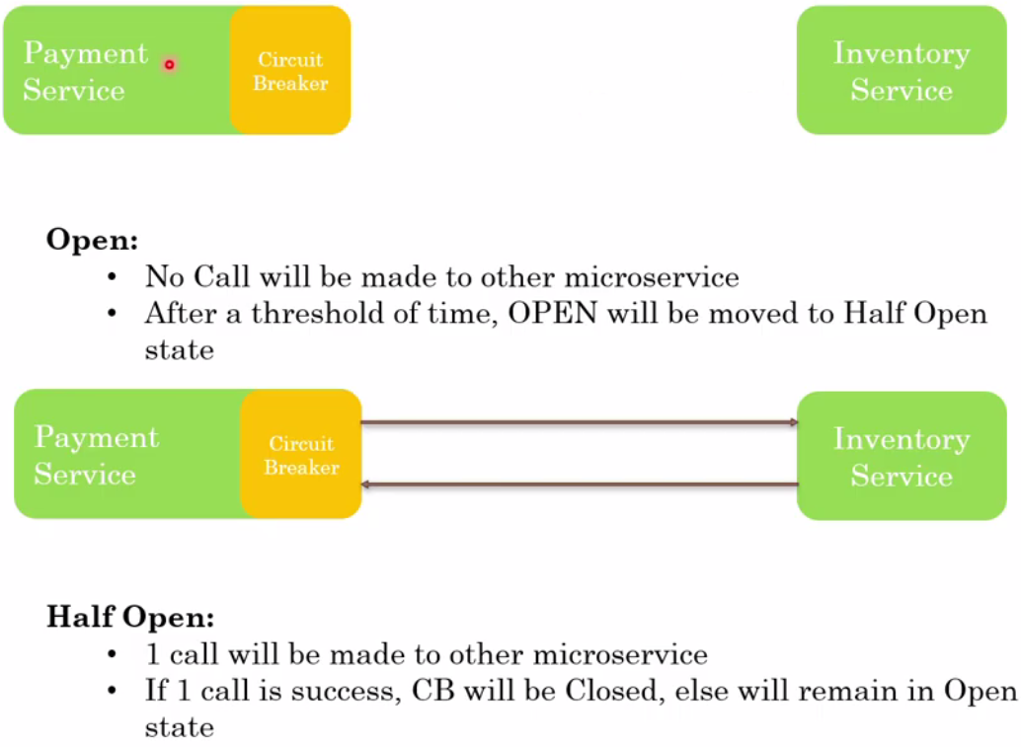

So as when payment service –circuit breaker does not receive any response from the inventory service in defined time span the Circuit breaker just trips the circuit and in this case no call will be made to each other and this state is called open state. In the open state the payment service will not send any request to inventory service for some time and will wait for its recovery, and after sometime again it will send request to inventory service and if calls is success then CB will be closed, otherwise will remain in open state. And this called Half Open state.

**Benefit to circuit breaker**:

In case of failure of any service the dependent service will not keep sending to request and waiting their response so we can say that we will have better resource utilization.

The use need not to wait for response unnecessary in case of failure, so we will have better user experience.

This can be used for better monitoring based on which service is tripping frequently

Helps us in understanding the issue and makes application more fault tolerant



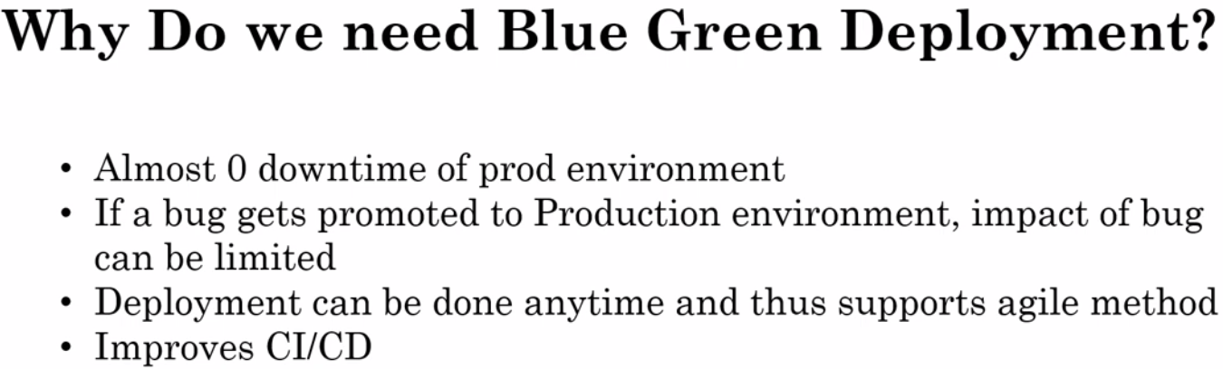

**How this Blue Green Deployment works?**

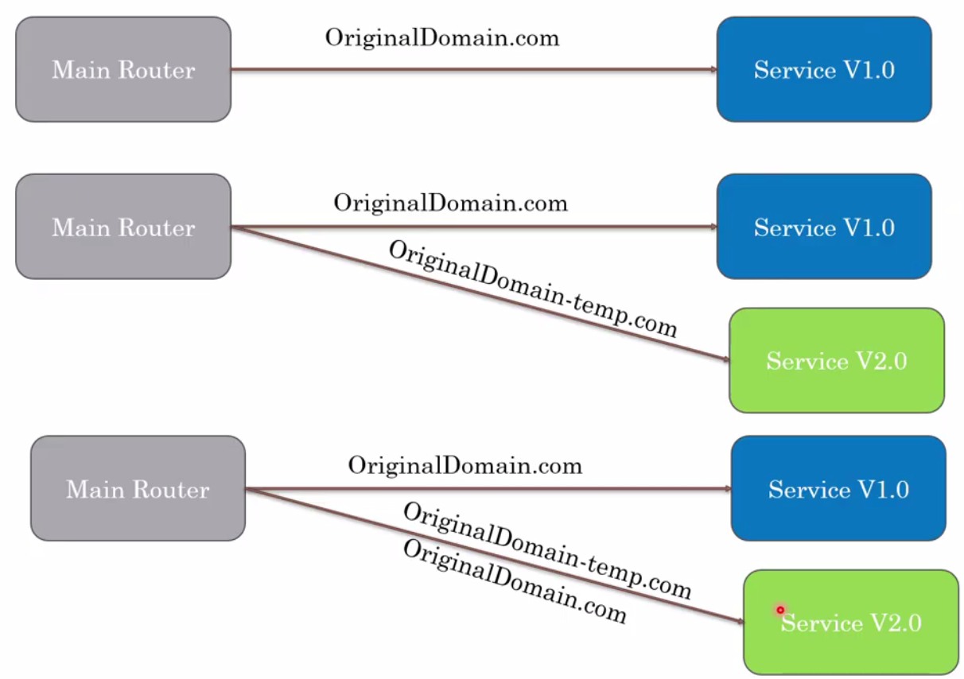

Create the temporary domain like prod and routed it to green deployment and now without going complete downtime of Blue existing we can start testing this green deployed having new or bug fix can be tested and we can route few real user for testing so if anything is not working in green deployed service then it would affect few users only and we have enough time to fix that and once everything looks fine then we can route original domain to green

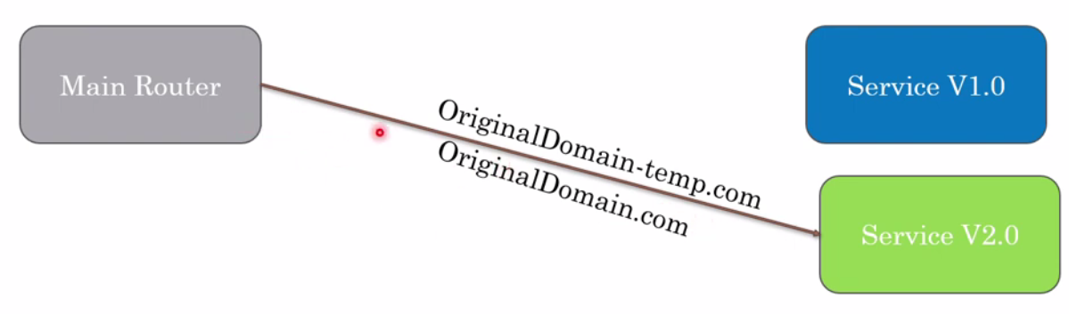

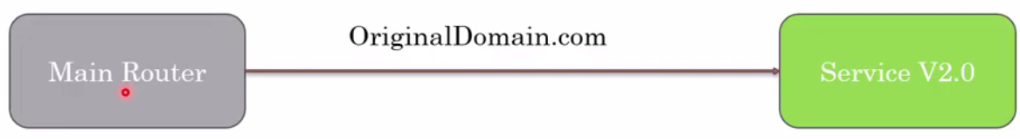

Once everything looks fine finally we can remove blue old service and make live green service with original domain.

